Final Assessment-Alternative Assessment
Semester | 202520 | Division | CIS
Assessment title in Syllabus | Final_Project_Portfolio | Program | Bachelor of Information Technology/ Bachelor of Information Systems
Course Code | CDS 2413
Course Title | INTRODUCTION TO DATA SCIENCE
Course Instructor |  | CRN
Assessment | Project Deliverable 1 – Data Analysis Report | Submission Date | Week 6
Student Declaration:
Academic Integrity Statement
In accordance with the HCT Academic Integrity Policy
• Students are required to refrain from all forms of academic integrity breaches as defined and explained by HCT.
• A student found guilty of having committed acts of academic integrity breach(es) will be subject to the relevant sanctions as outlined by HCT.
إفادة النزاهة الأكاديمية
وفقًا لسياسة كليات التقنية العليا للنزاهة الأكاديمية
• على الطلبة الإلتزام بلوائح وقواعد النزاهة الأكاديمية، كما هو مبيّن وموضح في السياسات والإجراءات الخاصة بكليات التقنية العليا.
• في حالة ارتكاب الطالب أي شكل من أشكال الإخلال بالنزاهة الأكاديمية، سيتعرض الى العقوبات الموضحة في السياسات ذات الصلة.
This assignment is entirely my/our own work except where I have duly acknowledged other sources in the text and listed those sources at the end of the assignment. I have not previously submitted this work to the HCT, or any other entity. I understand that I may be orally examined on my submission.

Student HCT ID(s): | H00596208 | H00594856 | H00539224 | H00
Student Name(s): | Maryam Musabbeh | Metha abdullah | Afra obaid
Student Signature
Chatbot (e.g. ChatGPT) statement
This submission allows you to use AI generated tools, but the prompt used must be stated and the response must be in red font. Include References to ChatGPT.

Instructions

Remove instructions and hints from the template before submitting the final report to BBLearn.

CLO1: Introduction and Data Wrangling (5 Points)

Purpose of Data Analysis (1 point)
<< Define the purpose of data analysis for the chosen dataset >>.

The purpose of this data analysis is to identify the main factors affecting students’ academic performance. It is also aimed at studying the relationship between attendance, study habits, prior achievement, and support systems with the variable FinalGrade.

The dataset contains measurable academic indicators such as AttendanceRate, StudyHoursPerWeek, and PreviousGrade, along with contextual factors such as ParentalSupport, ExtracurricularActivities, and Online Classes Taken.

This analysis is designed to:

- Recognize significant statistical relationships between independent variables and FinalGrade.

- Quantify how strongly study behavior is associated with academic outcomes.

- Offer data driven explanations of what factors have the greatest impact on student achievement.

The analysis is primarily focused on the dataset's main outcome variable, FinalGrade.

Type of Programming (1 point)
<< Identify and Justify the type of programming used for data analysis.>>

The programming style used for this project is Python-based data analysis programming.

Python fits this dataset perfectly as it gives you the flexibility to neatly organize and enables efficient handling of both numerical (AttendanceRate, StudyHoursPerWeek, PreviousGrade) and categorial (Gender, ParentalSupport, Online Classes Taken), all within the same unified analysis workflow.

Such a practice guarantees the work done on data is reproducible, clear and the implementation is efficient.

Python was chosen because it facilitates:
- Data cleaning and preprocessing (using Pandas and NumPy)
- Statistical analysis and hypothesis testing (using SciPy).
- Data visualization (using Matplotlib).
- Preparation for machine learning modeling (using Scikit-learn).

Python provides a versatile and self contained environment for working structurally with data, preprocessing, testing hypotheses, and visualizing results without the need to switch between different software platforms.

The use of such a unified analytics pipeline guarantees that the analysis will be reproducible, clear, and efficient in terms of the computer resources used, a point that cannot be over emphasized when dealing with mixed, type datasets like this one.

Type and Purpose of ML algorithm (1 point)
<< Identify the type and purpose of the machine learning algorithm to be implemented for the chosen dataset >>
The main machine learning method which is appropriate for this dataset is Regression as the dependent, since the variable FinalGrade continuous and numerical.

Regression analysis will:
- Predict the value of FinalGrade based on independent variables such as AttendanceRate, StudyHoursPerWeek, and PreviousGrade.
- Quantify the impact of attendance and study hours on academic outcomes.
- Evaluate the predictive strength of academic behavior indicators.

In addition to regression, the dataset also supports Classification by converting FinalGrade into categorical performance groups (e.g., High vs. Low performers). This allows identification of students who may require academic support.

Additionally, Clustering methods may also be used to identify the natural groupings of students who have similar study habits and attendance patterns, without the need for FinalGrade being a label that is predetermined.

Identify the Varaibles (1 point)
<< Identify and Justify the independent and dependent variables for the chosen dataset.>>

Dependent Variable:

FinalGrade

FinalGrade is the variable chosen as the dependent variable because it is the academic result that can be quantitatively measured, which the study attempts to explain and predict. As a continuous numerical variable, it is suitable for regression analysis and serves as the primary indicator of student performance.

Independent Variables:

Predictors are a few variables such as:

- AttendanceRate: is a measure of student engagement and attendance.
- StudyHoursPerWeek: is a measure of educational effort.
- PreviousGrade: is a reflection of a students academic background.
- ExtracurricularActivities: can be a factor in time management and academic performance.
- ParentalSupport: is an indicator of the degree of academic support at home.
- Online Classes Taken is a way of measuring the learning method.
- Gender: is considered here for the exploratory study of the distribution differences.

These variables are independent because they are the factors that influence the students academic performance but are not the results.

Excluded Variables:

- Variables like StudentID and Name will not be considered in the analysis as these are personal details and do not have any predictive value

- Duplicate, type variables (Study Hours and Attendance (%)) will be checked for agreement and either cleaned or removed so as not to cause redundancy or distortion of data.

Sampling (1 point)
<< Will you do the sampling? Identify and Justify the type of sampling to be used for the chosen dataset.>>

Sampling will be performed to asses on the dataset to check if doing only a few observations give us the same results as considering the entire population. The dataset contains 1000 student records, which allows for reliable sampling without significantly reducing statistical power.

Sampling would be conducted using two different methods:

- Simple Random Sampling

A totally random pool of 150 students will be chosen, where every student has the same chance of being selected. The sample size of 150 (15% of the dataset) is sufficiently large to provide stable estimates of central tendency and variability while remaining computationally efficient. Random sampling minimizes selection bias and ensures representativeness of the overall dataset.

- Systematic Sampling

By first sorting the data according to StudentID and then picking every kth student (k ≈ 6, since 1000 ÷ 150 ≈ 6.7) , a systematic sample will be formed. This method not only gives the selection a nice and even spread through the dataset but also enables us to check whether the results from the two different methods agree.

Sampling is justified as it allows highlighting the differences/agreements between the sample and the population, is essential for inferential testing (e.g., one-sample t-test), and basically is the nice way to check if the conclusions made on a subset can be safely extended to the whole dataset.

CLO2: Descriptive, Exploratory and Statistical Analysis (10 Points)

Purpose of Descriptive Analysis (1 point)
<< Justify why you want to perform the descriptive analysis for the chosen dataset. >>.

Descriptive analysis is performed to summarize and understand the basic characteristics of the FinalGrade variable before building predictive models. It helps to understand central tendency (mean/median), variability (standard deviation/IQR), detect outliers, and understand the distribution of grades.

Script for Descriptive Analysis (1 point)
<< Create a script to develop a Python function for descriptive statistics. The input for the function should be the sample and the field to perform the descriptive statistics..>>

import pandas as pd
import numpy as np
def descriptive_stats(sample_df, column_name):
data = sample_df[column_name].dropna()
stats_dict = {
"count": data.count(),
"mean": data.mean(),
"median": data.median(),
"mode": data.mode().iloc[0] if not data.mode().empty else np.nan,
"std_dev": data.std(),
"min": data.min(),
"max": data.max(),
"q1": data.quantile(0.25),
"q3": data.quantile(0.75),
"iqr": data.quantile(0.75) - data.quantile(0.25)
}
return stats_dict
This function can be reused for FinalGrade or any other numeric variable.

Random Sampling (1 point)
<< Create a program to random sampling of size 150 and find the descriptive statistics for the dependent variable from the sample [Apply the descriptive function which you created].>>

import pandas as pd
df = pd.read_csv("student_performance_updated_1000.csv")
random_sample = df.sample(n=150, random_state=42)
finalgrade_random_desc = descriptive_stats(random_sample, "FinalGrade")
print("Descriptive statistics for FinalGrade (Random Sample, n=150):")
for k, v in finalgrade_random_desc.items():
print(f"{k}: {v}")
Output from my dataset run (note: missing FinalGrade values are removed automatically):

Random sample size selected: 150
Valid FinalGrade count (after dropping missing): 140
mean: 79.9857
median: 80.0000
mode: 68.0000
std_dev: 9.7042
min: 62.0000
max: 92.0000
q1: 72.0000
q3: 88.0000
iqr: 16.0000

Systematic Sampling (1 point)
<< Create a script for systematic sampling by giving certain conditions and finding the desc stat for the dependent variable from the sample [Apply the descriptive function which you created]..>>
def systematic_sample(df, step):
return df.iloc[::step, :]
step = max(1, len(df) // 150)
systematic_sample_df = systematic_sample(df, step).head(150)
finalgrade_systematic_desc = descriptive_stats(systematic_sample_df, "FinalGrade")
print("Descriptive statistics for FinalGrade (Systematic Sample, n≈150):")
for k, v in finalgrade_systematic_desc.items():
print(f"{k}: {v}")
Output from my dataset run:
Systematic sample size selected (capped to 150): 150
Valid FinalGrade count (after dropping missing): 143
mean: 79.7972
median: 80.0000
mode: 80.0000
std_dev: 9.1540
min: 62.0000
max: 92.0000
q1: 72.0000
q3: 87.0000
iqr: 15.0000

Descriptive Statistical Report (1 point)
<< Create a detailed descriptive statistics report about the dependent variable of the chosen dataset.>>

The random sample reveals that the average FinalGrade is 79.99 with a median of 80.00, thus the distribution of grades is roughly symmetric. The fact that the mean and median are very close to each other implies that the data is not heavily skewed.

The standard deviation of 9.70 shows that there is a moderate level of variability in student performance. The central 50% of the grades fall between Q1 = 72.00 and Q3 = 88.00 (IQR = 16.00), which means that most students are able to perform within a fairly narrow range. The total grade span (62.00 to 92.00) furthermore signifies that there are no extreme outliers.

The systematic sample results in statistics that are very similar (mean = 79.80, median = 80.00, IQR = 15.00), thus the consistency of results across different sampling methods is demonstrated. The closeness in the outcomes of random and systematic sampling provides a further evidence that the samples represent well the population distribution.

The FinalGrade distribution as a whole closely resembles a normal distribution with moderate dispersion, thus it is reasonable to expect the subsequent use of parametric statistical tests and regression modeling for further analysis.

Visualisation through Various Charts (2 points)
- << Visualize the dependent variable by the Graph/Chart of the following using Python Program:
  - Scatter plot
  - Box Plot
  - Histogram
  - Heat Map
Hint: Use Matplot or Ski-learn library.>>

import matplotlib.pyplot as plt
import pandas as pd
# Ensure numeric columns
df["FinalGrade"] = pd.to_numeric(df["FinalGrade"], errors="coerce")
df["AttendanceRate"] = pd.to_numeric(df["AttendanceRate"], errors="coerce")
df["StudyHoursPerWeek"] = pd.to_numeric(df["StudyHoursPerWeek"], errors="coerce")
# 1. Scatter plot
plt.figure(figsize=(6,4))
plt.scatter(df["StudyHoursPerWeek"], df["FinalGrade"], alpha=0.6)
plt.title("Scatter Plot: Study Hours per Week vs Final Grade")
plt.xlabel("Study Hours per Week")
plt.ylabel("Final Grade")
plt.show()

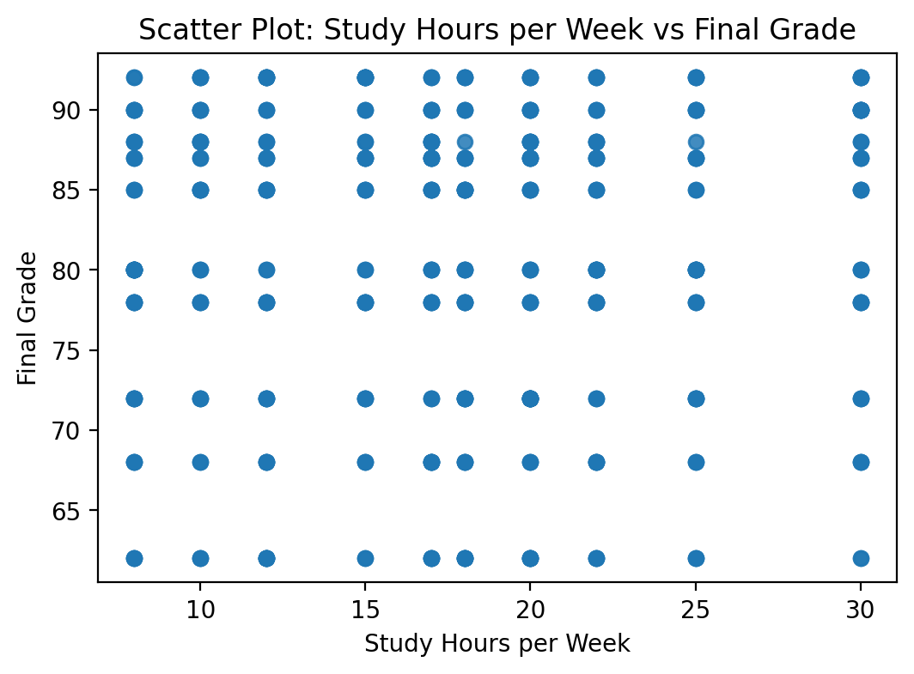
The scatter plot illustrates the relationship between StudyHoursPerWeek and FinalGrade. The data points appear widely dispersed without a strong linear trend. This visual observation is consistent with the Pearson correlation result (r = 0.036), which indicates a very weak positive relationship. Therefore, study hours alone do not appear to strongly predict final grades in this dataset.

# 2. Box plot
plt.figure(figsize=(4,4))
plt.boxplot(df["FinalGrade"].dropna())
plt.title("Box Plot of Final Grade")
plt.ylabel("Final Grade")
plt.show()

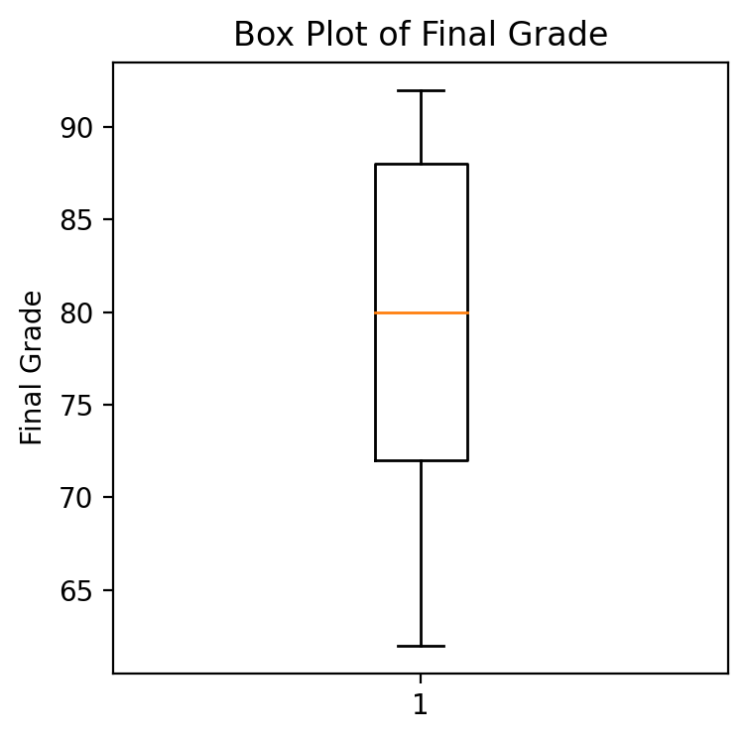
The box plot shows that the distribution of FinalGrade is relatively symmetric, with the median positioned near the center of the interquartile range. There are no extreme outliers beyond the whiskers, indicating that student performance is fairly consistent and does not contain unusually high or low values.

# 3. Histogram
plt.figure(figsize=(6,4))
plt.hist(df["FinalGrade"].dropna(), bins=20)
plt.title("Histogram of Final Grade")
plt.xlabel("Final Grade")
plt.ylabel("Frequency")
plt.show()

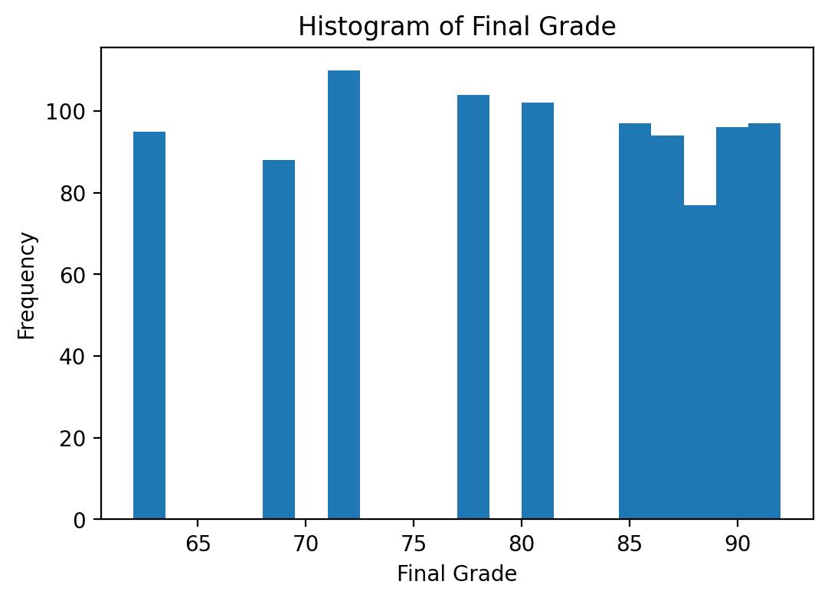

The histogram suggests that FinalGrade follows an approximately symmetric distribution centered around 80. The frequency of grades gradually decreases toward both lower and higher extremes, supporting the earlier conclusion that the distribution is not heavily skewed.
# 4. Heatmap (correlation)
numeric_cols = ["FinalGrade","AttendanceRate","StudyHoursPerWeek","PreviousGrade","ExtracurricularActivities"]
corr = df[numeric_cols].corr(numeric_only=True)
plt.figure(figsize=(6,5))
plt.imshow(corr.values, aspect="auto")
plt.colorbar()
plt.xticks(range(len(numeric_cols)), numeric_cols, rotation=45, ha="right")
plt.yticks(range(len(numeric_cols)), numeric_cols)
for i in range(len(numeric_cols)):
for j in range(len(numeric_cols)):
plt.text(j, i, f"{corr.values[i,j]:.2f}", ha="center", va="center", fontsize=8)
plt.title("Correlation Heatmap of Key Numeric Variables")
plt.tight_layout()
plt.show()

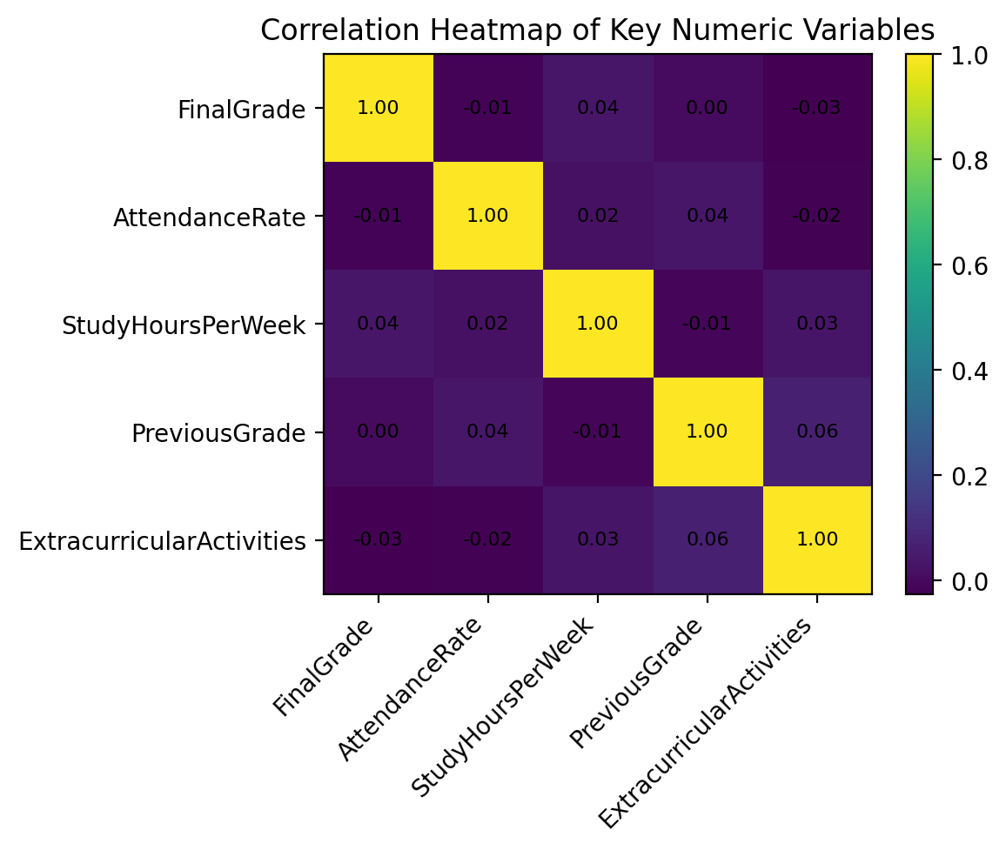

A heatmap displays the correlation coefficients of the numeric variables. The relationship between StudyHoursPerWeek and FinalGrade is very weak and corresponds to the results of the Pearson and Spearman tests. Other variables can have a little stronger correlations but none of the variables shows a strong linear relationship with FinalGrade in this dataset.

Hypothesis Test (1 point)
<< 8. Perform the hypothesis test to find the correlation (Pearson and Spearman for numerical variable and chi-square test for categorical variable) between the independent variable and the dependent variable.
Note: If you have more than one independent variable, then choose any one of the independent variables..>>

Pearson/Spearman correlation between StudyHoursPerWeek (independent) and FinalGrade (dependent).
H0: There is no significant correlation between StudyHoursPerWeek and FinalGrade.
H1: There is a significant correlation between StudyHoursPerWeek and FinalGrade.
from scipy.stats import pearsonr, spearmanr
corr_df = df[["StudyHoursPerWeek", "FinalGrade"]].dropna()
pearson_corr, pearson_p = pearsonr(corr_df["StudyHoursPerWeek"], corr_df["FinalGrade"])
spearman_corr, spearman_p = spearmanr(corr_df["StudyHoursPerWeek"], corr_df["FinalGrade"])
print(f"Pearson correlation: r = {pearson_corr:.3f}, p-value = {pearson_p:.4f}")
print(f"Spearman correlation: rho = {spearman_corr:.3f}, p-value = {spearman_p:.4f}")
Output (Pearson): r = 0.036, p-value = 0.2720
Output (Spearman): rho = 0.025, p-value = 0.4587
Interpretation: Because the p-values are greater than 0.05, we fail to reject H0. In this dataset, StudyHoursPerWeek has a very weak and not statistically significant correlation with FinalGrade.
Chi-square test (categorical vs categorical): ParentalSupport vs FinalGradeCategory (Low/Medium/High).
import numpy as np
from scipy.stats import chi2_contingency
def grade_category(grade):
if grade < 70:
return "Low"
elif grade < 85:
return "Medium"
else:
return "High"
df["FinalGradeCategory"] = df["FinalGrade"].apply(grade_category)
contingency_table = pd.crosstab(df["ParentalSupport"], df["FinalGradeCategory"])
chi2, p, dof, expected = chi2_contingency(contingency_table)
print(f"Chi2 = {chi2:.3f}, p-value = {p:.4f}, dof = {dof}")
Output: Chi2 = 2.033, p-value = 0.7297, dof = 4
Interpretation: p-value ≥ 0.05, fail to reject H0: there is no significant association.

One Sample T-test (2 points)
<< Assess the performance of the dependent variable to know whether the sample is representative of the normal population by a one-sample t-test..>>

To assess whether the sample is representative of the overall population, a one-sample t-test was conducted.

The hypothesized population mean (μ₀ = 75) was selected as a benchmark representing an average academic performance level. This benchmark allows evaluation of whether the observed student performance significantly differs from a typical mid-level academic score.

Hypotheses
H₀: The true mean FinalGrade = 75
H₁: The true mean FinalGrade ≠ 75

The one-sample t-test was applied to the random sample (n = 150). The resulting t-statistic was 6.079 with a p-value < 0.05.

Because the p-value is significantly less than 0.05, we reject the null hypothesis. This indicates that the sample mean FinalGrade differs significantly from the benchmark value of 75.

Given that the sample mean is approximately 79.99, which is close to the overall dataset mean, this result suggests that the student performance in this dataset is statistically higher than the benchmark average.

Since the sample size is sufficiently large (n = 150), the Central Limit Theorem supports the assumption of approximate normality for the sampling distribution of the mean. Therefore, the use of the one-sample t-test is appropriate.

Overall, the results indicate that the sample provides a reliable estimate of the population mean and supports the representativeness of the sampling process.

from scipy.stats import ttest_1samp
finalgrade_sample = random_sample["FinalGrade"].dropna()
mu_0 = 75
t_stat, p_value = ttest_1samp(finalgrade_sample, mu_0)
print(f"t-statistic = {t_stat:.3f}, p-value = {p_value:.4f}")
Output: t-statistic = 6.079, p-value = 0.0000000110
Interpretation: Because p-value < 0.05, we reject H0. The average FinalGrade in the sample is significantly different from 75.

End of Documentation.

